DAY – 1 (26/09/22)

***Object Oriented Programming with C++.***

**Programs:**

1. Write a C++ Program to print Your Name.

#include<iostream>

using namespace std;

int main()

{

cout<<"Hari Krishnan\n";

}

**Output:**

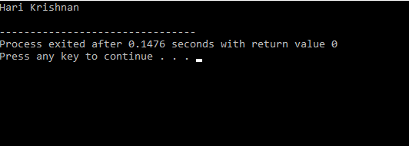

1. Write a C++ Program to find the mathematical Operations.

**Program:**

#include<iostream>

using namespace std;

int main()

{

int a,b,c,d,e,f,g;

cout<<"Enter the value of A = ";

cin>>a;

cout<<"Enter the value of B = ";

cin>>b;

c=a+b;

d=a-b;

e=a*b;

f=a/b;

g=a%b;

cout<<"\nsum of A and B = "<<c;

cout<<"\ndifference of A and B = "<<d;

cout<<"\nproduct of A and B = "<<e;

cout<<"\ndivision of A and B = "<<f;

cout<<"\nModulus of A and B = "<<g;

return 0;

}

**Output:**

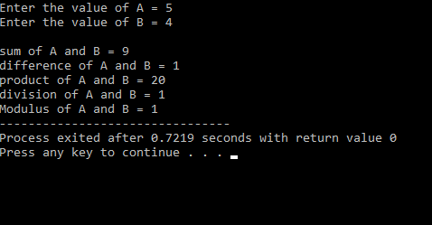

1. Write a C++ program to find the biggest of two numbers.

**Program:**

#include<iostream>

using namespace std;

int main()

{

int a,b;

cout<<"Enter the value of A and B = ";

cin>>a>>b;

if(a>b)

{

cout<<"A = "<<a<<" is the greater";

}

else

{

cout<<"B = "<<b<<" is the greater";

}

return 0;

}

**Output:**

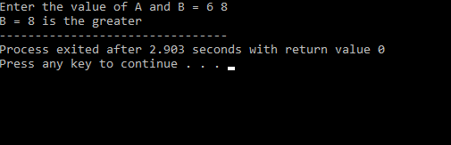

1. Write a C++ program to find the given number is Odd or Even.

**Program:**

#include<iostream>

using namespace std;

int main()

{

int n;

cout<<"Enter the value of N = ";

cin>>n;

if(n%2==0)

{

cout<<"The given value if Even";

}

else

{

cout<<"The given value if Odd";

}

return 0;

}

**Output:**

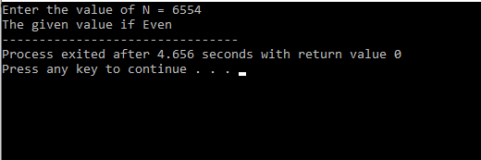

1. Write a C++ Program to find the person is eligible for voting or not:

**Program:**

#include<iostream>

using namespace std;

int main()

{

float a;

int r;

cout<<"Enter your age = ";

cin>>a;

r=a/1;

if(a>0)

{

if(a>=0 && r*1==a)

{

if(a>=18)

{

cout<<"You are eligible";

}

else

{

cout<<"You are not Eligible for voting";

}

}

else

{

cout<<"Invalid input";

}

}

else

{

cout<<"Invalid Input";

}

return 0;

}

**Output:**

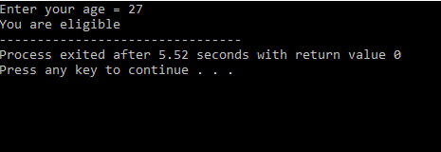

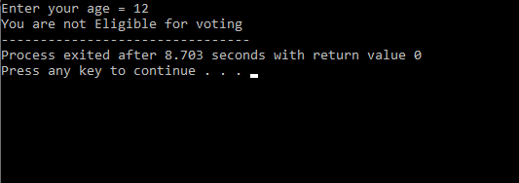

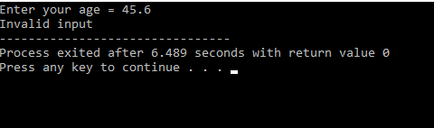

1. Write a C++ program to print the student report using the given Inputs:

**Program:**

#include<iostream>

using namespace std;

int main()

{

int r,r1,r2,r3;

char name[10];

float a,b,c,tot,avg;

cout<<"Enter the value of M1 = ";

cin>>a;

cout<<"Enter the value of M2 = ";

cin>>b;

cout<<"Enter the value of M3 = ";

cin>>c;

r1=a/1;

r2=b/1;

r3=c/1;

if(a>0 && b>0 && c>0)

{

if(a>=0 && r1*1==a && b>=0 && r2*1==b && c>=0 && r3*1==c)

{

if(a>50 && a<=100 && b>50 && c<=100 && a>50 && a<=100)

{

tot=a+b+c;

avg=tot/3;

cout<<"total = "<<tot;

if(avg>90)

{

cout<<"\nAvg ="<<avg<<"\nGrade:S";

}

else if(avg>80 && avg<=90)

{

cout<<"Avg ="<<avg<<"\nGrade:A";

}

else if(avg>70 && avg<=80)

{

cout<<"Avg ="<<avg<<"\nGrade:B";

}

else if(avg>60 && avg<=70)

{

cout<<"Avg ="<<avg<<"\nGrade:C";

}

else if(avg>50 && avg<=60)

{

cout<<"Avg ="<<avg<<"\nGrade:D";

}

else

{

cout<"No Grade is Alloted";

}

}

else

{

cout<<"You Failed or Invalid input";

}

}

else

{

cout<<"\nInvalid Input";

}

}

else

{

cout<<"\nInvalid Input";

}

return 0;

}

**Output:**

